**Exercises**

1. Display name and job of all the teachers in UPPER, lower and Camel case.

Query:

select TeacherName,Job, upper(TeacherName) as TeacherNameUpper, upper(Job) as JobUpper from Teacher

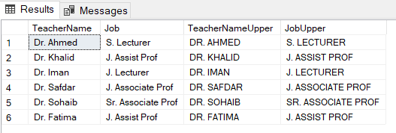

1. Generate new names of the students by combining the first 3 characters of Phone Numbers and last 3 characters of Names.

Query:

select StdName,StdPhone, concat(substring(StdPhone,1,3),substring(StdName,len(StdName)-2,3)) as StdNewName from Std

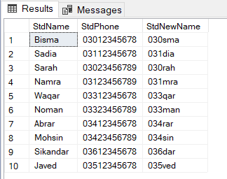

1. Generate new names of the students by replacing letter ‘a’ with ‘sh’.

Query:

select StdName,replace(StdName,'a','sh') as StdNameReplaced from Std

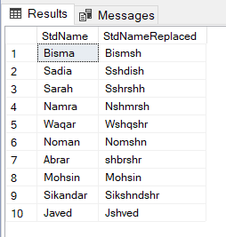

1. Display Name and years served in the university by the Teacher.

Query:

select TeacherName, datediff(year,TeacherDOJ,getdate()) as yearServed from Teacher

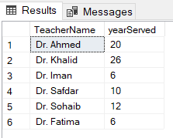

1. Display name, job and date of joining of all the faculty who were born before Jan 31 2004. Keeping this in mind that joining dates should be displayed in the format “MONTH DATE, YEAR”. Also date in the where clause should be in the format “MONTH DATE, YEAR”.

Query:

select TeacherName,Job,TeacherDOJ,format(TeacherDOJ,'mm-dd-yyyy') as TeacherDOJFormated from Teacher where TeacherDOB < '01-31-2004'

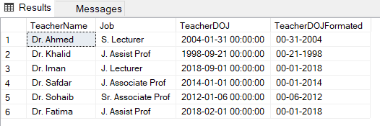

1. Display the names of all teachers along with their house rent or 'Not given' if the house rent is null.

Query:

select TeacherName,HouseRent,isnull(cast(HouseRent as varchar),'not given') as HouseRentReplaced from Teacher

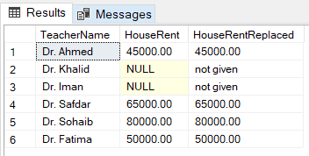

1. Display teacher name, basic salary, house rent and total salary (Basic Sal + House Rent) of all the faculty members. Keeping this in mind that house rent of some of the employees might be null but total salary of an employee must not be null.

Query:

select TeacherName,BasicSalary,HouseRent,(BasicSalary+isnull(HouseRent,0)) as TotalSalary from Teacher

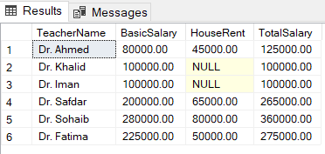

1. Display the name, job, total salary, and bonus of all the faculty members. If the job is 'S. Lecturer,' calculate the bonus as 20% of the basic salary. For 'J. Assist Prof' or 'S. Assist Prof,' the bonus is 25% of the basic salary. If the job is 'J. Associate Prof' or 'S. Associate Prof,' the bonus is 30% of the basic salary. Include a column indicating whether the bonus was awarded or not.

Query:

select TeacherName,Job,BasicSalary,(BasicSalary+isnull(HouseRent,0)) as TotalSalary,

case

when Job = 'S. Lecturer' or Job = 'J. Lecturer' then BasicSalary*0.20

when Job = 'J. Assist Prof' or Job = 'S. Assist Prof' then BasicSalary*0.25

when Job = 'J. Associate Prof' or Job = 'Sr. Associate Prof' then BasicSalary*0.30

else NULL

end as EmpBonus

from Teacher

